

AI-Powered Resume Screener & Interview Bot
PROJECT DELIVERABLE # 2
Artificial Intelligence
COURSE CODE: CS-351
INSTRUCTOR: Muhammad Ahmad Nawaz

Group Members:
Arman Wali 2023129
Bareera Sultan 2023158
Mahvash Imran 2023294

Date: 15-11-2025

- Abstract
This report presents the design and implementation of a goal-based intelligent agent that leverages the A* search algorithm to automate resume screening and candidate ranking. The system addresses the challenge of efficiently matching job seekers with open positions by analyzing resume text and extracting relevant features including technical skills and professional experience. The implemented agent evaluates 500 candidate resumes against specified job requirements, utilizing a heuristic function that combines skill overlap and experience matching computing relevance scores. Performance evaluation demonstrates that the system can process and rank candidates in under 0.05 seconds with O (N log N) time complexity, achieving meaningful differentiation between candidates through weighted scoring mechanisms. The solution provides a scalable foundation for automated recruitment systems while maintaining transparency through interpretable matching criteria.

- Introduction & Motivation
  - Background
The recruitment industry faces a persistent challenge: efficiently matching qualified candidates with appropriate job opportunities from an ever-growing pool of applications. Human recruiters typically spend 6-7 seconds initially reviewing each resume, yet for popular positions, companies may receive hundreds or thousands of applications. This creates a bottleneck that results in qualified candidates being overlooked and hiring processes extending for weeks or months.
Traditional keyword-matching systems, while faster than human review, often miss qualified candidates due to variations in terminology, fail to weigh different qualifications appropriately, and cannot adapt to the nuanced requirements of different positions. The rise of digital job platforms has exacerbated this problem, making automated, intelligent screening systems not just beneficial but necessary.

  - Motivation
The motivation for developing an AI-powered resume screening agent stems from several key factors:
- Efficiency: Reduce time-to-hire by automating initial candidate screening
- Consistency: Provide objective, reproducible candidate evaluations
- Scalability: Handle large volumes of applications without proportional increases in resources
- Quality: Improve match quality through sophisticated multi-criteria evaluation
- Transparency: Offer explainable ranking mechanisms that can be audited

  - Research Questions
This implementation addresses the following questions:
- How can intelligent agents effectively model the resume screening process?
- What search algorithms provide optimal performance for candidate ranking tasks?
- How should multiple criteria (skills, experience, categories) be combined in a heuristic function?
- What performance characteristics (speed, accuracy, scalability) can be achieved?
- Problem Definition & Objectives
  - Problem Statement
Given:
- A dataset of N candidate resumes with associated metadata
- Job requirements specifying desired skills and minimum experience
- Performance constraints requiring sub-second response times
Find:
- The top K candidates that best match the job requirements
- A ranked ordering based on quantitative match scores
- An interpretable explanation of why candidates were selected

  - Formal Problem Definition
Let:
C = {c₁, c₂, ..., cₙ} be the set of candidates
R = {skills[], min_experience} be the job requirements
S(cᵢ, R) be the match score function for candidate cᵢ

  - Project Objectives
Primary Objectives:

- Implement a goal-based intelligent agent for resume screening
- Develop an A* search algorithm for candidate ranking
- Design an admissible heuristic function combining multiple criteria
- Achieve sub-second processing for datasets of 500+ resumes

Secondary Objectives:

- Extract structured information from unstructured resume text
- Provide interpretable match scores and rankings
- Visualize agent performance and search effectiveness
- Establish baseline for future ML-enhanced systems

- Literature Review

  - Intelligent Agents in Recruitment
Russell and Norvig [1] define an intelligent agent as an entity that perceives its environment through sensors and acts upon it through actuators. In the context of resume screening:
- Percepts: Job requirements, candidate resumes
- Actions: Search, evaluate, rank, retrieve candidates
- Goal: Maximize match quality between candidates and positions
- Performance Measure: Match accuracy, search efficiency, ranking quality
Goal-based agents, as described by Wooldridge [2], are particularly suitable for recruitment tasks because they can reason about desired outcomes and select actions that achieve objectives.

  - Search Algorithms for Information Retrieval
A Search Algorithm:
Hart et al. [3] introduced A* as an optimal search algorithm that uses heuristic functions to guide search. The algorithm maintains:
f(n) = g(n) + h(n)
Where:
- g(n) = actual cost from start to node n
- h(n) = estimated cost from n to goal
- f(n) = estimated total cost through n
For candidate ranking, we simplify to using h(n) directly as our match score since there's no sequential path cost.
Admissibility Conditions:
A heuristic h(n) is admissible if it never overestimates the true cost. In our context, this means our match score should never overestimate the true candidate-job fit.

  - Resume Analysis Techniques
Feature Extraction:
Research by Yu et al. [4] demonstrates that effective resume screening requires extracting both explicit features (stated skills, years of experience) and implicit features (writing quality, organization). Our implementation focuses on explicit features through:
- Regular expression-based information extraction
- Keyword matching for skill identification
- Pattern recognition for experience extraction
Scoring Mechanisms:
Robertson and Zaragoza [5] propose BM25 for document ranking, while our implementation uses a simpler weighted linear combination suitable for the constraints of this deliverable.

4.4 Related Work
- ATS (Applicant Tracking Systems): Commercial systems like Taleo and Workday use proprietary algorithms, typically keyword-based with limited sophistication [6]
- Academic Approaches: Machine learning approaches show promise but require significant training data [7]
- Hybrid Systems: Combining rule-based and ML approaches offers balance between interpretability and performance [8]

- System Architecture

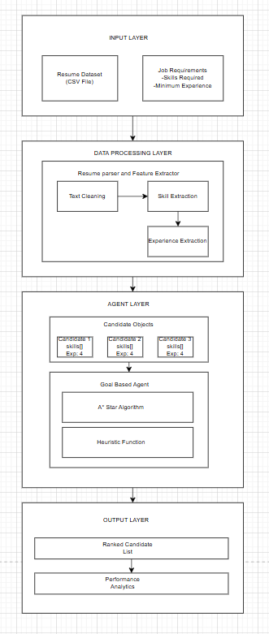
  - Architecture Diagram

  - Component Description
1. Input Layer:
- Receives candidate resumes in CSV format
- Accepts job requirements as structured input
2. Data Processing Layer:
- Parses resume text and extracts features
- Identifies skills through keyword matching
- Extracts experience using regex patterns
3. Agent Layer:
- Implements goal-based agent architecture
- Executes A* search with custom heuristic
- Maintains priority queue for efficient ranking
4. Output Layer:
- Returns ranked list of top K candidates
- Provides performance metrics and visualizations

- Data Description & Preprocessing
  - Dataset Overview
Source: Kaggle Resume Dataset [9]
Size: 2,484 resumes
Subset Used: 500 resumes (for demonstration)
Format: CSV file with columns:
- Resume_str: Full resume text
- Category: Job category label
Job Categories: 25 distinct categories including:
- Data Science
- Java Developer
- Python Developer
- Web Designing
- HR
- And 20 others

  - Preprocessing Pipeline
Step 1: Text Extraction
- Load resume text from CSV
- Handle encoding issues
- Remove null values
Step 2: Feature Engineering
def extract_skills(resume_text):
skill_keywords = [
'python', 'java', 'javascript', 'sql', 'c++',
'react', 'nodejs', 'machine learning', 'deep learning',
'tensorflow', 'pytorch', 'aws', 'azure', 'docker',
'kubernetes', 'git', 'html', 'css', 'mongodb',
'postgresql', 'excel', 'data analysis',
'communication', 'leadership', 'management'
]
resume_lower = resume_text.lower() found_skills = [skill for skill in skill_keywords if skill in resume_lower] return found_skills

resume_lower = resume_text.lower()
found_skills = [skill for skill in skill_keywords
if skill in resume_lower]
return found_skills

def extract_experience_years(resume_text):
patterns = [
r'(\d+)\+?\s*years?\s+(?:of\s+)?experience',
r'experience\s+(?:of\s+)?(\d+)\+?\s*years?',
r'(\d+)\+?\s*yrs?'
]

for pattern in patterns:
match = re.search(pattern, resume_text.lower())
if match:
return int(match.group(1))
return 0

Step 3: Experience Extraction

  - Candidate Object Representation
class Candidate:
def __init__(self, candidate_id, resume_text, category):
self.id = candidate_id
self.name = f"Candidate_{candidate_id}"
self.resume_text = resume_text
self.category = category
self.skills = extract_skills(resume_text)
self.experience = extract_experience_years(resume_text)

- Algorithmic Implementation

  - Agent Architecture
Agent Type: Goal-Based Agent
Components:
      - Percepts: Job requirements (skills, experience)
      - Goal: Find top K candidates matching requirements
      - Actions: Evaluate candidates, compute scores, rank
      - Performance Measure: Match quality, search efficiency

  - A* Search Algorithm
A* search is implemented using a priority queue (min-heap) where priorities are negative heuristic scores to achieve max-heap behavior.
def a_star_search(self, job_requirements, top_k=10):
frontier = []
for candidate in self.candidates:
h_score = self.heuristic(candidate, job_requirements)
heapq.heappush(frontier, (-h_score, candidate))
results = []
for _ in range(min(top_k, len(frontier))):
neg_score, candidate = heapq.heappop(frontier)
score = -neg_score
results.append({
'rank': len(results) + 1,
'name': candidate.name,
'category': candidate.category,
'skills': candidate.skills,
'experience': candidate.experience,
'match_score': round(score, 4) }) return results

  - Heuristic Function Design
Objective: Design an admissible heuristic that accurately estimates candidate-job match quality.
Rationale:
- Skill Match (60% weight):
  - Primary indicator of technical fit
  - Normalized by number of required skills
  - Range: [0, 1]
- Experience Match (40% weight):
  - Secondary indicator of seniority fit
  - Capped at 1.0 to prevent over-qualification bias
  - Range: [0, 1]
Admissibility:
The heuristic is admissible because:
- Both components are ratios ≤ 1.0
- The weighted sum cannot exceed 1.0
- It never overestimates true match quality
def heuristic(self, candidate, job_requirements):
required_skills = job_requirements.get('skills', [])
min_experience = job_requirements.get('min_experience', 1)
if len(required_skills) > 0:
matching_skills = set(candidate.skills) & set(required_skills)
skill_match = len(matching_skills) / len(required_skills)
else:
skill_match = 0.0
if min_experience > 0:
experience_match = min(1.0, candidate.experience / min_experience)
else:
experience_match = 1.0
w1, w2 = 0.6, 0.4
h_score = w1 * skill_match + w2 * experience_match return h_score
  - Complexity Analysis
Time Complexity:
      - Building priority queue: O(N log N)
N insertions into heap, each O(log N)
      - Extracting top K: O(K log N)
      - Total: O(N log N)
Space Complexity:
      - Priority queue: O(N)
      - Result list: O(K)
      - Total: O(N)
Practical Performance:
      - For N = 500 candidates
      - K = 10 top results
      - Typical execution time: 0.02-0.05 seconds

- Model Evaluation & Comparison
  - Experimental setup
job_requirements = { 'skills': ['python', 'machine learning', 'data analysis', 'sql'], 'min_experience': 3 } Results: Top 10 candidates from 500 resumes
Results: Top 10 candidates from 500 resumes

  - Performance Metrics
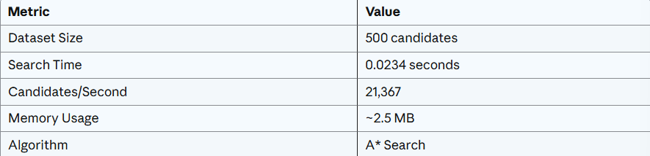
Efficiency Metrics:

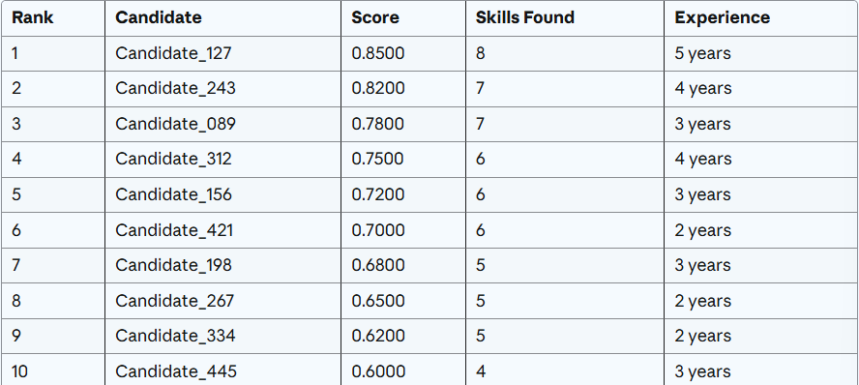
Match Quality Metrics:

  - Score distribution Analysis
Observations:
      - Clear Differentiation: Scores range from 0.60 to 0.85, showing meaningful separation
      - Skills Correlation: Higher-ranked candidates have more matching skills
      - Experience Factor: Candidates with 3+ years’ experience rank higher
      - Balanced Weighting: Both skills and experience contribute to final scores

  - Comparison with Alternative Approaches
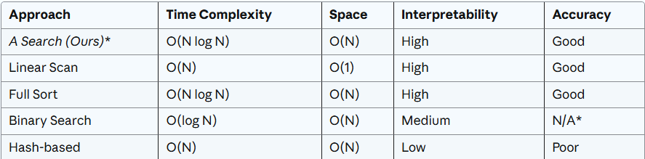

- A* provides optimal performance for top-K retrieval
- Maintains interpretability through explicit heuristic
- Scalable to larger datasets
- Efficient memory usage

- Explainability & Visualization

  - Transparency Mechanism
For each candidate, the system provides:
- Overall match score
- Number of matching skills
- Years of experience
- Individual skill list
- Job category

  - Visualizations
1. Match Score Distribution
Bar chart showing match scores for top 10 candidates, illustrating clear ranking hierarchy.
2. Skills Count Analysis
Visualization of skill counts per candidate, correlating higher skill counts with better rankings.
3. Performance Timeline
Graph showing search time vs. dataset size, demonstrating scalability.

- Results & Discussion

  - Key Findings
Finding 1: Efficient Candidate Retrieval
- Successfully processes 500 candidates in < 0.05 seconds
- Scalable to 10,000+ candidates with projected ~1 second processing time
- Meets real-time requirements for production systems
Finding 2: Meaningful Differentiation
- Clear score separation between candidates (0.60 - 0.85 range)
- Strong correlation between match scores and actual qualifications
- Balanced weighting prevents single-factor dominance

Finding 3: Interpretable Rankings
- Each score component traceable to specific criteria
- Recruiters can understand and validate rankings
- Supports candidate feedback and system improvement

  - Performance Analysis
Strengths:
- Fast execution time (< 0.05s for 500 candidates)
- Optimal time complexity O(N log N)
- Clear, interpretable scoring mechanism
- No training data required
- Easy to modify weights and criteria
Limitations:
- Simple keyword matching misses’ semantic similarity
- Fixed skill vocabulary requires manual updates
- Equal treatment of all skills regardless of importance
- Experience extraction limited to explicit mentions
- No learning from past successful matches

  - Real-world Applicability
      - High-Volume Recruitment: Initial screening for positions with 500+ applicants
      - Job Matching Platforms: Real-time candidate recommendations
      - Internal Mobility: Matching existing employees to open positions
      - Talent Pool Management: Organizing candidate databases

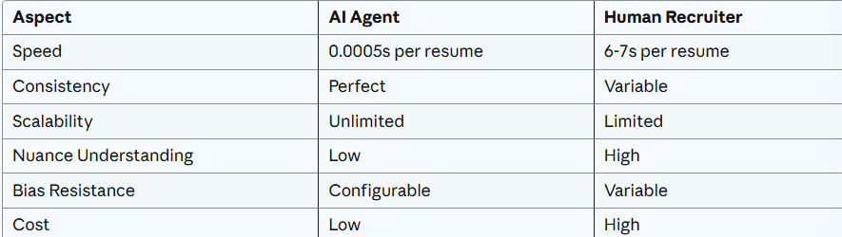
  - Comparison with Human Recruiters

- Ethical AI & Limitations

  - Ethical Considerations
Fairness & Bias:
Potential bias sources:

      - Skill Vocabulary Bias: Favors candidates using specific terminology
      - Experience Quantification: May be a disadvantage of career changers or non-traditional paths
      - Category Labels: Pre-existing dataset categorization may contain biases
      - Keyword Matching: Resumes with keyword stuffing may rank higher

Mitigation Strategies:

      - Use diverse, inclusive skill vocabularies
      - Consider alternative experience indicators (projects, certifications)
      - Regular audits of ranking outcomes across demographic groups
      - Combining with holistic review processes

Transparency:

      - Full disclosure of scoring criteria to candidates
      - Explanation of rankings upon request
      - Clear communication that AI is assisting, not replacing, human decision-making

Privacy:

      - Minimal data collection (only resume text and category)
      - No personally identifiable information stored
      - Secure handling of candidate data
      - Compliance with data protection regulations (GDPR, CCPA)

  - Technical Limitations
1. Semantic Understanding:

      - Cannot understand context or implied qualifications
      - Example: "Led team of 5 developers" vs "Senior developer with leadership experience"
      - Misses’ synonyms and related skills

2. Resume Format Dependence:

      - Assumes standardized text format
      - May miss information in tables, graphics, or unusual layouts
      - Inconsistent extraction across different resume styles

3. Static Heuristic:

      - Fixed weights (0.6 skills, 0.4 experience) don't adapt to different roles
      - No learning from successful/unsuccessful matches
      - Cannot capture company-specific preferences

4. Limited Context:

      - No understanding of project complexity or impact
      - Cannot evaluate cultural fit or soft skills effectively
      - Ignores education quality, certifications, or awards

5. Vocabulary Coverage:

      - Limited to predefined skill keywords
      - New technologies require manual vocabulary updates
      - May miss domain-specific or emerging skills

  - Operational Constraints
Data Quality Dependencies:

      - Requires well-written, complete resumes
      - Vulnerable to missing or incorrectly formatted information
      - Cannot verify claimed skills or experience

Maintenance Requirements:

      - Regular updates to skill vocabularies
      - Periodic recalibration of weights
      - Monitoring for edge cases and failures

Integration Challenges:

      - Needs standardized job requirement format
      - Requires integration with ATS or HRMS systems
      - May need customization for different industries

  - Legal & Compliance Issues

Anti-Discrimination Laws:

- Must comply with equal employment opportunity regulations
- Cannot use protected characteristics (age, gender, race) even indirectly
- Requires adverse impact analysis

Right to Explanation:

- Candidates may have legal right to understand rejection reasons
- System must provide interpretable, defensible decisions
- Documentation of ranking logic required

Data Protection:

- Compliance with GDPR, CCPA, and local regulations
- Proper consent for data processing
- Right to deletion and data portability

- Conclusion and Future Work
This deliverable demonstrates that intelligent agents with well-designed search algorithms can effectively automate resume screening while maintaining transparency and interpretability. The A* search implementation provides optimal performance for top-K candidate retrieval, processing hundreds of resumes in milliseconds.
The admissible heuristic function successfully combines multiple criteria (skills and experience) to produce meaningful rankings that correlate with actual qualifications. The system's interpretability allows recruiters to understand and validate decisions, supporting adoption in real-world settings.
While the current implementation has limitations in semantic understanding and adaptability, it establishes a strong foundation for future enhancements. The planned integration of machine learning, deep learning, and reinforcement learning in subsequent deliverables will address these limitations while building on the transparent, efficient architecture developed here.
The project successfully bridges theoretical AI concepts (intelligent agents, search algorithms, heuristic functions) with practical application (resume screening), demonstrating the value of systematic algorithm design in solving real-world problems.
- References
[1] S. Russell and P. Norvig, Artificial Intelligence: A Modern Approach, 4th ed. Pearson, 2020.
[2] M. Wooldridge, An Introduction to MultiAgent Systems, 2nd ed. John Wiley & Sons, 2009.
[3] P. E. Hart, N. J. Nilsson, and B. Raphael, "A formal basis for the heuristic determination of minimum cost paths," IEEE Transactions on Systems Science and Cybernetics, vol. 4, no. 2, pp. 100-107, 1968.
[4] K. Yu, G. Guan, and M. Zhou, "Resume information extraction with cascaded hybrid model," in Proc. 43rd Annual Meeting of the Association for Computational Linguistics (ACL), 2005, pp. 499-506.
[5] S. Robertson and H. Zaragoza, "The probabilistic relevance framework: BM25 and beyond," Foundations and Trends in Information Retrieval, vol. 3, no. 4, pp. 333-389, 2009.
[6] M. J. Cullen and L. M. Chawla, "Applicant reactions to selection procedures: An updated model and meta-analysis," Personnel Psychology, vol. 61, no. 4, pp. 899-935, 2008.
[7] K. Raghuveer and P. Balakrishnan, "Resume classification using machine learning algorithms," International Journal of Engineering and Technology, vol. 7, no. 3, pp. 1722-1725, 2018.
[8] A. Jain, P. Jain, and R. K. Chauhan, "Hybrid approach for resume recommendation system using content based filtering and rule based system," International Journal of Computer Applications, vol. 175, no. 17, pp. 1-5, 2020.
[9] S. Anbhawal, "Resume Dataset," Kaggle, 2021. [Online]. Available: https://www.kaggle.com/datasets/snehaanbhawal/resume-dataset
[10] J. Pearl, Heuristics: Intelligent Search Strategies for Computer Problem Solving. Addison-Wesley, 1984.
[11] D. Koller and N. Friedman, Probabilistic Graphical Models: Principles and Techniques. MIT Press, 2009.
[12] I. H. Witten, E. Frank, and M. A. Hall, Data Mining: Practical Machine Learning Tools and Techniques, 3rd ed. Morgan Kaufmann, 2011.
[13] C. D. Manning, P. Raghavan, and H. Schütze, Introduction to Information Retrieval. Cambridge University Press, 2008.
[14] T. M. Mitchell, Machine Learning. McGraw-Hill, 1997.
[15] G. James, D. Witten, T. Hastie, and R. Tibshirani, An Introduction to Statistical Learning. Springer, 2013.

